16th March 2021

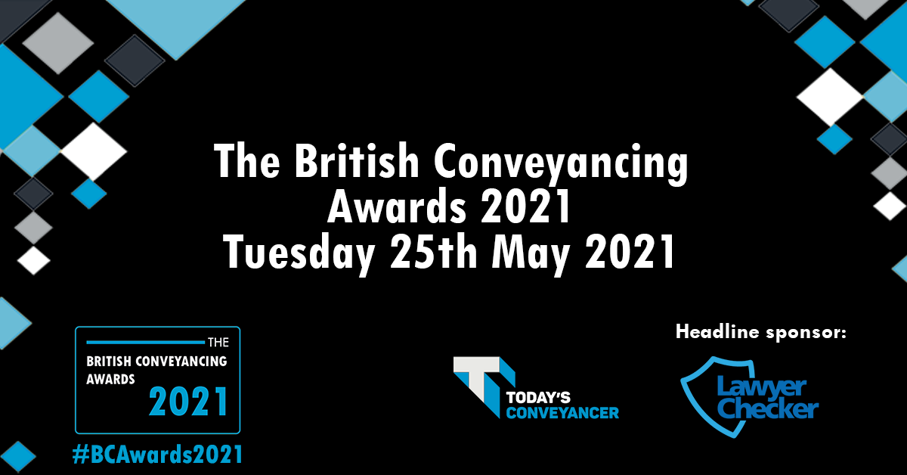

Lawyer Checker - proud headline sponsor of the inaugural British Conveyancing Awards

Lawyer Checker is delighted to announce that we are headline sponsor for the new British Conveyancing Awards 2021.

Taking place virtually on the 25th May 2021 the awards will recognise and reward champions from across the conveyancing sector, who have gone above and beyond in these challenging times.

Organiser of the event - leading digital platform for conveyancing news - Today’s Conveyancer, understand how much pressure professionals in the sector currently face. With this in mind, video award entry submissions are welcomed to keep precious time to a minimum, and written submissions kept down to 500 words.

Karen Babington, Commercial Director at Lawyer Checker commented on the company’s sponsorship; “At Lawyer Checker we’re thrilled to be playing our part in recognising the dedication, hard work and resilience from conveyancing professionals over the past year.

“The Award’s bespoke categories have been designed to recognise individuals, teams and companies who have contributed to assisting customers to move home, despite the intense pressures they have been under. We’re really excited to hear the individual stories from firms and to collectively recognise their herculean efforts in the face of such adversity.”

The categories have been carefully chosen to recognise the efforts of the industry throughout the pandemic, shining a light on way in which the industry has responded.

Best IT Team award

Best Use of Marketing award

Best Use of Social Media award

Best Young Practitioner of the year award

Mental Health & Wellbeing Conveyancing Firm of the Year

Community involvement award

Innovation of the year of award

Technology team of the year award

Conveyancing Customer Service Champion

Business Development Professional of the year award

Equality, Diversity and Inclusion Award

“Risen to the Challenge” Legal Secretary of the Year

New Business Champion of the year award

Best New Training Initiative award

Risk and Compliance Champion of the Year award

Outstanding Business Leader of the Year award

Best Direct to Consumer Offering award

Best Panel Manager of the Year

Conveyancing Practitioner of the Year

Collaborator Champion

Lawyer Checker would like to encourage early entrant submissions with an ‘early bird’ discount in place for nominees to take advantage of. The discount at £129 plus VAT enables entrance to three categories. The discount runs till 21st March 2021. Then the price will increase to £169 plus VAT to enter up to three categories. To secure this discounted rate, conveyancers only need to register their interest here at this stage.

For more information on Lawyer Checker:

Diane Turner

diane.turner@praticalvision.co.uk
0330 335 9100
www.lawyerchecker.co.uk

For more information on Today’s Conveyancer and The British Conveyancing Awards:
Grace Beech
grace.beech@practicalvision.co.uk
01829 307798
www.todaysconveyancer.co.uk

